HEY, WHERE’S

MY TRANSITION PLAN?
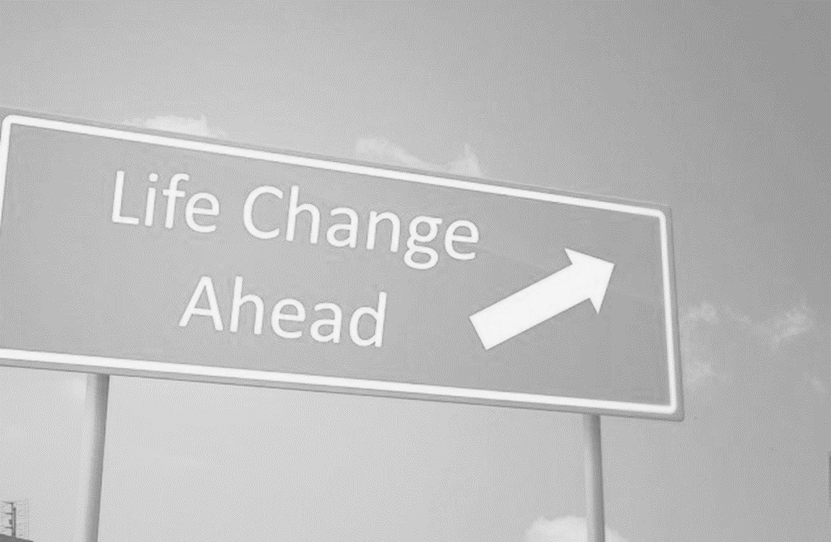
A TRAINING FOR YOUTH SELF-ADVOCACY PRESENTED BY:
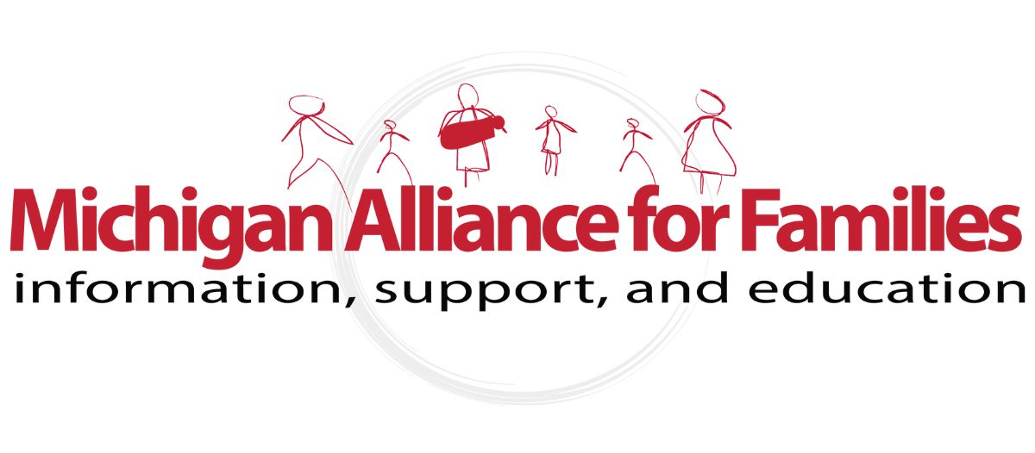

TABLE OF CONTENTS

- What is Transition? 5
- Transition Services 9
- Advice from Other Students 10
- Self-Advocacy Checklist 12
- The Rules Change 14
- Where to Call Home? 16
- Accessing Your Community 19
- Transition Resources 21

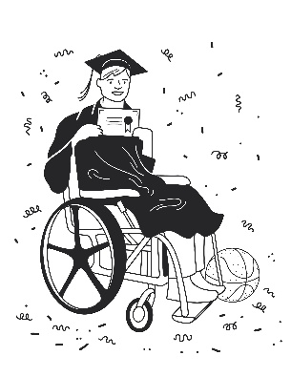
This workbook is intended to help you begin the transition to after school life. Please feel free to take notes on each of the pages and make this book your own!

WHAT IS TRANSITION?

Transition means changing from one thing to another. In our case, it’s about your future and where it will lead after you leave high school.

Transitions can be exciting because the next step you take will be a whole new adventure. Transitions can also be a little scary because you might have to learn how to do things you haven’t done before, and you may not be sure what to expect.

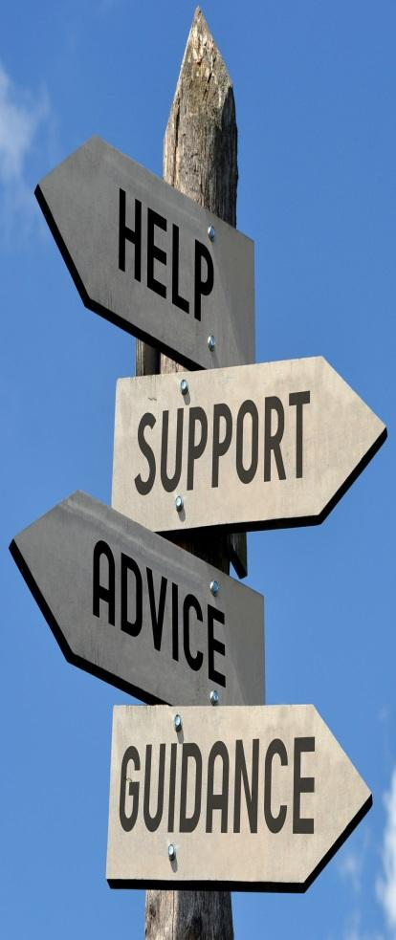

I KEEP HEARING ABOUT
‘TRANSITION PLANNING.’ WHAT IS IT?
When your parents, teachers or other adults in your school talk about “transition planning,” they are talking about things you can do now to get ready for the time after you leave high school. That future may seem far away, but the more you plan now, the easier your first steps into the adult world will be.

When you were a young child, the grown-ups in your life probably did most of the planning for your future. That’s okay, because that was their job. The difference between being a young child and being a teenager is that planning for your future becomes your job. You need to decide on your dreams and goals for the future. Good transition planning will help you achieve those dreams. Now, you already have something called an Educational Development Plan, or EDP. All high school students in Michigan have an EDP. This is a document that describes what you're interested in, and what type of career you might like, and the steps you will take to get there. EDPs help you think about long-term education and career plans before entering high school. In Michigan, transition planning is required to start by the time you are 16 years old, if you have an Individualized Education Program (IEP).

You need to choose goals that matter to you. That means you need to figure out where you want to be and what you want to be doing.

WHAT DOES MY INDIVIDUALIZED EDUCATION PROGRAM (IEP) HAVE TO DO WITH TRANSITION PLANNING?

Your Individualized Education Program (IEP) is like a GPS or roadmap.

It shows where you are going and how you are going to get there. “Individualized” means ALL about you. Your IEP should show the goals you want to reach and the supports you need to reach them.

By paying attention to what’s in your IEP, you can help make sure that you learn the skills you will need to do what you want with your life after you graduate. Your transition plan is part of your IEP. It is not a separate document. A good transition plan includes instruction, community participation and activities to support your goals.

Ask your teacher about a student led IEP meeting. This puts you in the driver's seat!

LEARNING HOW TO SPEAK UP FOR
YOURSELF CAN BE HARD!

Once you know what you want and need, you must be able to tell other people.

That’s the only way to make your dreams come true!

Transition preparation:
- takes several years
- involves a lot of different people
- requires learning new skills
- helps develop a plan to help you reach your dreams!

WHAT DO PEOPLE MEAN WHEN THEY TALK ABOUT TRANSITION SERVICES?

Transitions often mean that you must try doing things you haven’t done before. The good news is that you don’t have to figure out how to do all this by yourself. You can ask other people to help you when you need it.

To help students prepare for what they want to do after school, a team of people should help decide what transition services can be helpful. Transition services include college or other education after high school, vocational education, integrated employment (including supported employment), adult services, independent living, and/or community participation.

Other supports can help you too. Sometimes we might need a person to help or maybe a thing (like a wheelchair or calculator). Sometimes we might need a service. Often, we need more than one kind of support.

Whatever you need, you can be sure it isn’t the same as what everyone else needs. The key is to figure out what supports would be the most helpful to meet your unique needs so that you can reach your unique goals.

Start work on transition planning early! Write down your goals, plans, and what you like.
Learn good communication skills so you can tell people what you want.
Learn about resources like SSI (Supplemental Security Income), vocational rehabilitation, mental health services, housing options, independent living centers, Medicaid waivers, college disability support services, adult services, and social groups and recreational activities. Get information on all available options.
ADVICE FROM
OTHER STUDENTS:

Take a more active role in meetings. Ask more questions!
Join groups that can help, like local advocacy groups, church groups, and community education classes.
Look into co-op and work-based learning programs which can be done through school.
Get more work experience by volunteering. Even better, try to work part-time for pay.

Take classes in independent living skills. Learn how to cook, do your laundry, clean your home, shop, budget, and how to recognize and count money.
Find out how to access community resources, services and emergency systems, and how to get help filling out forms.
Learn more about making good decisions, and then the self-advocacy skills to share them! Go for your dreams!

If you can, learn how to drive and get your driver's license! If that's not for you, learn how to use other transportation systems like the bus!
Be serious. Do your homework and budget your time. Learn to use a calendar or planner to write down your assignments and to help you plan time to study.
List your strengths and challenges. Find out what you're good at and build on those strengths. When possible, work to improve the areas that are hard.
Set goals and go for them! Don't be disappointed if you can't do everything though, no one can!
MY STRENGTHS…
- Something that I am good at is…
- Something I really like to do is…
- One thing that I am interested in is…
- One of my skills that I could use in my work is…
CHECKLIST: RATE YOUR
SELF-ADVOCACY SKILLS

I can do this | I need to work on this | I need help with this | Some of the skills I need to have my needs met
 |  |  | Talking about my disability
 |  |  | Knowing what my strengths are
 |  |  | Setting goals for myself
 |  |  | Working with others
 |  |  | Sharing my ideas with others
 |  |  | Knowing what I need to complete a task and requesting those accommodations
 |  |  | Knowing who I can trust to ask for help
 |  |  | Speaking up politely when I disagree
 |  |  | Asking questions when I don’t understand
 |  |  | Being active in my IEP & transition planning meetings
 |  |  | Being comfortable with my personal story and setting limits about what I share
 |  |  | Talking to my doctor about my healthcare
AFTER SCHOOL, THE RULES CHANGE!
BOTTOM LINE: Services available to you after you exit the school system are based on eligibility.

In college and at a workplace, you will have to find the services you want or need and show that you qualify for them. You will also have to provide proof that accommodations are necessary! This isn’t high school, but you can be prepared.

Employment
Many students choose to find employment instead of going full-time to college or technical training. Finding employment can take some time. Part of your transition planning goals should address employment. You can learn job skills and participate in different types of employment in your community. Getting skills and having a part-time job before graduation will make it easier to get the kind of job you want after high school.

Postsecondary education
Going to college or to a training school after high school will help increase your knowledge and prepare you for your chosen career. College provides a great opportunity to meet and socialize with other young adults. There are some services available through your college's student support services office. Contact them and learn what documents and other information regarding your disability they will need.
EXPLORING OPTIONS:

College

Training School
Exploring Options: College
Direct Employment

Vocational Rehabilitation

Vocational rehabilitation services may be useful. For those who qualify, rehabilitation Services provides individualized services to enhance and support people with disabilities to prepare for, obtain or retain employment. Everyone should apply!
WHERE DO YOU WANT TO CALL HOME?

Home is a special place. It’s where you live, the people you live with, and the things you want around you like furniture, pictures, music, plants and pets. It’s activities like cooking, eating, cleaning, celebrating, entertaining friends or relaxing, and spending some time by yourself.

Where will you live after high school? Do you want to live on your own or with others? Will you live with your family or move in with a roommate? Do you want to live in the city or out in the country?

Here are some choices of living arrangements:
- Buying a home is a dream for many people, but it can be hard to do right out of high school. You need to save a lot of money, have a steady job that pays enough money, and be able to show that you pay your bills on time. This might be something you want to plan to do in the future.
- Renting is when you pay someone money to live in a home or apartment that they own. It usually costs less than buying your own home. Renting a home costs money, too, but if you earn enough money, or have family that can help, or if you choose to live with other people so you can all share the expenses, renting a home might be something you can afford to do now.

WHO CAN HELP GET ME HOUSING I CAN AFFORD?
People with disabilities should have accessible housing. There may be vouchers, rental assistance, and other programs that can help with costs.

There are agencies that provide other choices for living arrangements:
- A few people live together (these are called group homes or waiver homes).
- People get the supports they need to live on their own in their own homes (this is called supported living).

Independent living means living in your own home. If you choose to live independently, you can receive the supports you need, but it will be your responsibility (with help from family and friends if you need it) to manage those supports. These supports are often paid for with a combination of your own money and money from a funding source like Medicaid. Medicaid waivers help pay for people with disabilities to live in their community with support. In Michigan, there are several kinds of waivers and most have a waiting list, so it is important to learn about these options early.

MY HOUSING CHOICES:
CHOICE 1

CHOICE 2

CHOICE 3

ADDITIONAL SUPPORTS I WILL NEED TO BE SUCCESSFUL IN THE COMMUNITY

ACCESSING YOUR COMMUNITY
How do you get to your friends' homes? When you need something from the store, how do you get there? When you are planning for life as an adult, you also must think about how you're going to get where you want to go.

If your parents or caregivers drive you where you need to go, have you talked about putting a driving schedule together that considers your time and their time? Is there a bus route that could take you where you need to go? What's stopping you from finding out? How can you find out what public transportation is in your area?

As part of your Individualized Education Program, transportation is something your IEP team should discuss and plan for. You may qualify to begin working with Vocational Rehabilitation to prepare to meet your transportation needs. Local areas may have transit services for people with disabilities.
DRIVER’S LICENSE AGE REQUIREMENTS

The state of Michigan has a Graduated Driver Licensing program for teens.
- Age 14 years and 8 months: students are eligible to start Segment 1 of Driver Education with an approved provider.
- Age 14 years and 9 months: students are eligible to apply for a Level 1 Learner’s License at their local Secretary of State office.
- Age 15: students are eligible to start Segment 2 of Driver Education with an approved provider.
- Age 16: students are eligible to apply for a Level 2 License with some restrictions.
- Age 17: students are eligible for a Level 3 License with full privileges.
- Secretary of State website: https://www.michigan.gov/sos
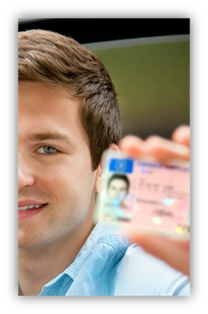

CIRCLE THE THINGS YOU WILL DO IN YOUR COMMUNITY:
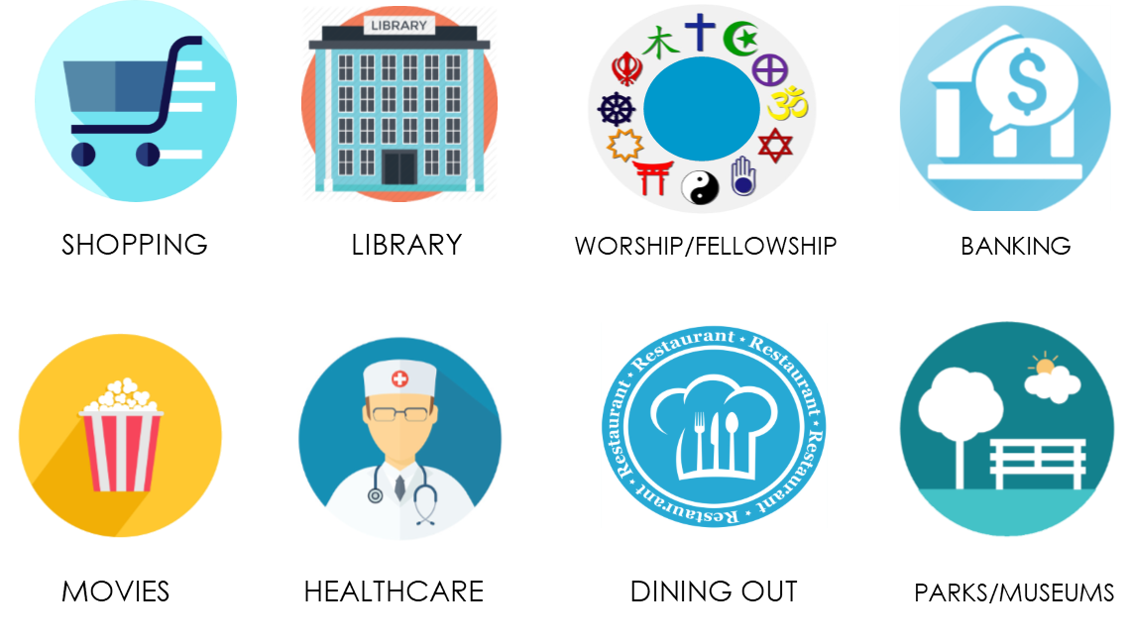

CIRCLE HOW YOU WILL GET TO THESE PLACES:
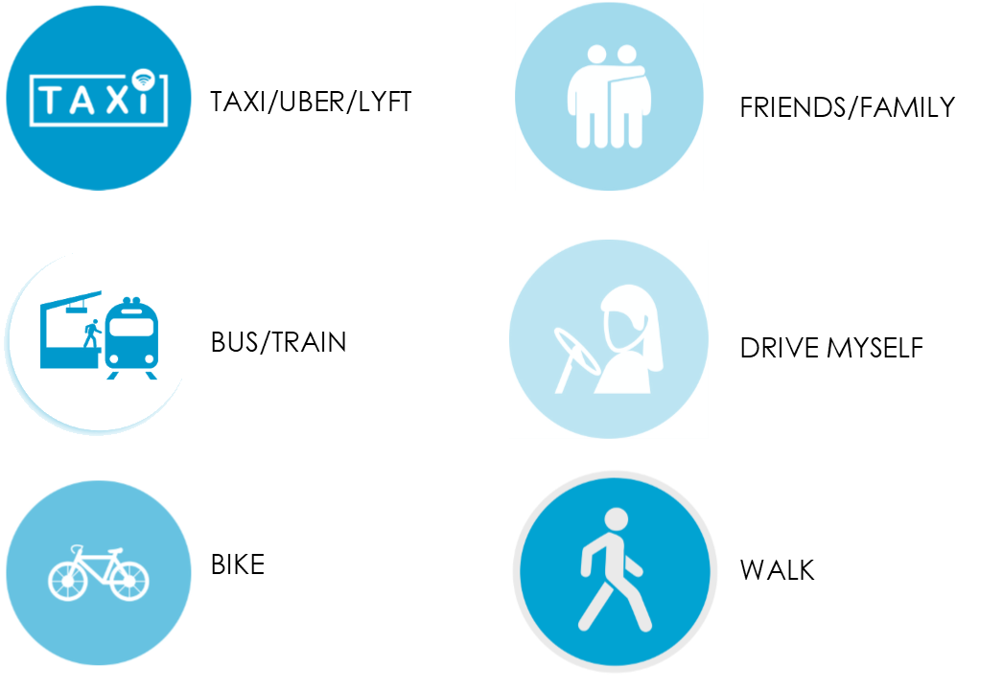
Transition Timeline From Special Education To Adulthood
Youth 12-15 Years Old
- Youth and counselor create Educational Development Plan (EDP) in 7th grade, to explore interests and career goals, and to plan high school course of study.
- EDP is reviewed and revised every year after 7th grade.
- Youth learns basic chores and self-care at home.
- Youth learns basic self-advocacy skills to express preferences and needs.
- Youth has a Social Security card and a medical alert tag, if needed.
- Youth may receive Pre-Employment Transition Services (Pre-ETS) from vocational rehabilitation (VR) starting at age 14.
- VR contact information:
- Michigan Rehabilitation Services (MRS), 1-800-605-6722
- Bureau of Services for Blind Persons (BSBP), 1-800-292-4200

Youth 16-17 Years Old
- Transition planning is included in IEPs at age 16.
- Youth is invited to every IEP where transition planning is discussed.
- By 17th birthday, school team explains to youth that they will become an adult at age 18 and will have certain legal rights.
- Youth has a state-issued photo ID or driver’s license.
- Michigan Secretary of State: https://www.michigan.gov/sos
- VR assists with placement in part-time paid work experience.

Adults 18 Years Old
- Adult and family choose a path to help the adult make decisions, such as a supported decision-making agreement or power of attorney.
- Adults may apply for Supplemental Security Income (SSI) and Medicaid.
- Social Security website: https://www.ssa.gov/
- Medicaid website: https://newmibridges.michigan.gov/
- After Medicaid approval, adults may enroll in Community Mental Health (CMH) services.
  - CMH agencies in Michigan: https://cmham.org/membership/cmhsp-directory/
- Male adults must apply for Selective Service (military draft) at age 18.
- Selective Service System: https://www.sss.gov/register/

Adults 19-25 Years Old
- Adult, CMH supports coordinator, and family identify services to support skill-building and increased community participation.
- Adult pursues post-secondary education, such as college, vocational training, or skill-building program.
- Adult participates in recreational activities and employment.

Adults 26+ Years Old
- Adult, CMH supports coordinator, and family identify appropriate housing.
- Adult continues to work toward post-secondary goals with CMH, VR, and community connections.
GREAT RESOURCES ON TRANSITION

www.gottransition.org/
Got Transition is a national resource center for information about health care transition for youth with special healthcare needs.

http://www.pacer.org/tatra/
National Parent Center on Transition and Employment features transition planning, education and employment resources.

ThinkCollege.net
Think College is a national initiative dedicated to developing, expanding, and improving research and practice in inclusive higher education for students with intellectual disability.

EMPLOYMENT RESOURCES

Michigan has two vocational rehabilitation agencies dedicated to helping people with disabilities achieve their employment goals. Students may become eligible for services starting at age 14. Contact the agency that best fits your needs:

Michigan Rehabilitation Services (MRS)
1-800-605-6722
Email: LEO-MRS-CustomerAssistance@michigan.gov
Website: www.michigan.gov/mrs

Bureau of Services for Blind Persons
1-800-292-4200
Website: www.michigan.gov/bsbp

HOUSING RESOURCES

www.michigan.gov/mshda
The Michigan State Housing Development Authority (MSHDA) helps create and preserve safe, affordable housing. The website has information on buying, renting, and housing vouchers.

arcmi.org/resource-center/its-your-life/housing/
The Arc Michigan makes sure that people with disabilities are valued so that they and their families can participate in and contribute to their communities. Statewide housing resources are available on this website.
ABOUT MICHIGAN ALLIANCE FOR FAMILIES

Michigan Alliance for Families is a statewide resource to connect families of children with disabilities to resources to help improve their children’s education. We help facilitate parent involvement as a means of improving educational services and outcomes for students with disabilities.
Michigan Alliance for Families can assist you in knowing your rights, effectively communicating your child’s needs, and advising how to help them develop and learn. Each Michigan Alliance staff member is a parent or family member of an individual with disabilities who has first-hand experience with the aspects of the special education system.
CONTACT US
Call 1-800-552-4821
En Español 313-217-1060
للغه العربيه 248-963-0607
info@michiganallianceforfamilies.org

At our website, https://www.michiganallianceforfamilies.org, you can access our online webinars, calendar of events, and a host of information related to special education.

Information and resources related to the transition to adulthood are located here:
https://www.michiganallianceforfamilies.org/transition/

Find us on Facebook, Instagram, and YouTube:

MichiganAllianceForFamilies​

@michiganallianceforfamilies​

/MichiganAlliance​

Michigan Alliance for Families is not a law firm or legal services agency.
Our employees are not attorneys and do not provide legal advice.

WITH SPECIAL THANKS

Adapted with permission from transition booklets created by:

Family Voices of Tennessee
www.tndisability.org/familyvoices

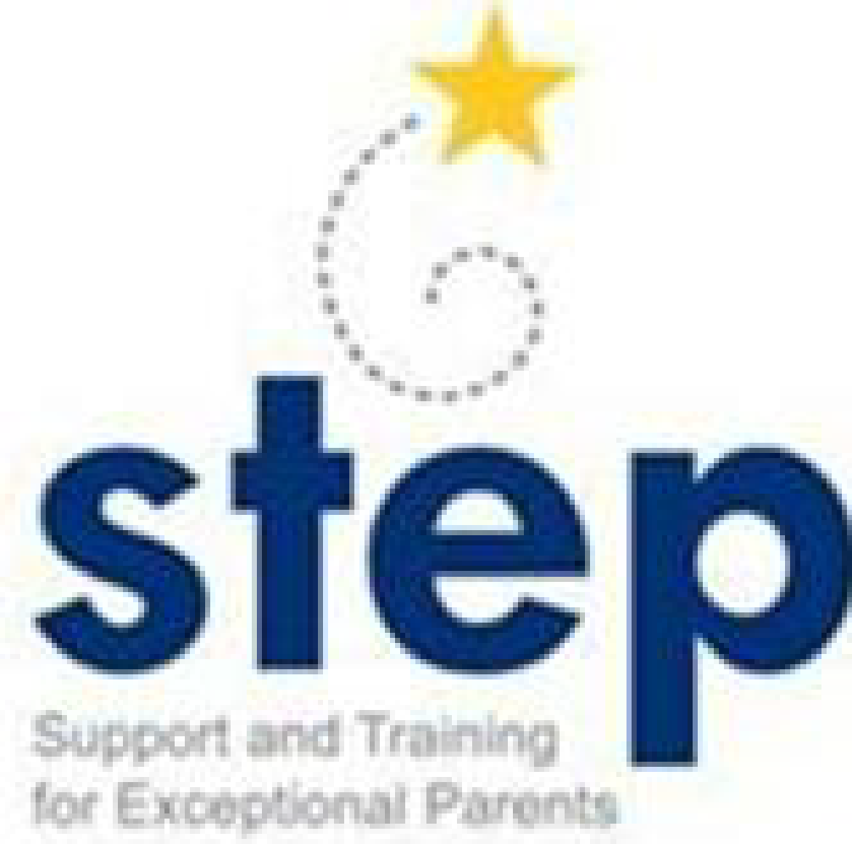
STEP, Inc.
www.tnstep.info
Tennessee’s Parent Training & Information Center

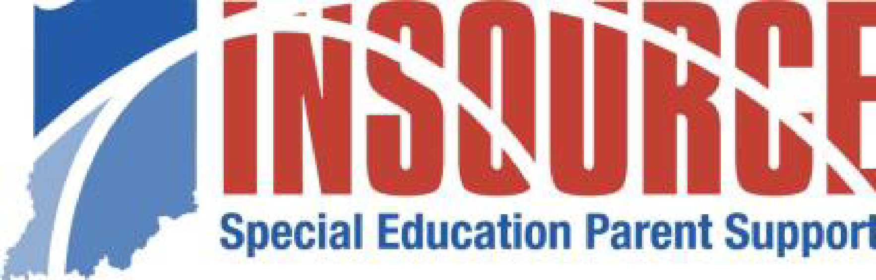
IN*SOURCE
insource.org
Indiana’s Parent Training & Information Center

NOTES

